**Check prime number using decision node**

This document will explain how to use Decision node.

Please go through the following sample automation **check prime number using decision node. Zappy** file.

**Step 1:** Right click on Zap icon and select Task Editor (or Double click on zap icon).

**Step 2:** Open the **“check prime number using decision node. Zappy”** automation.

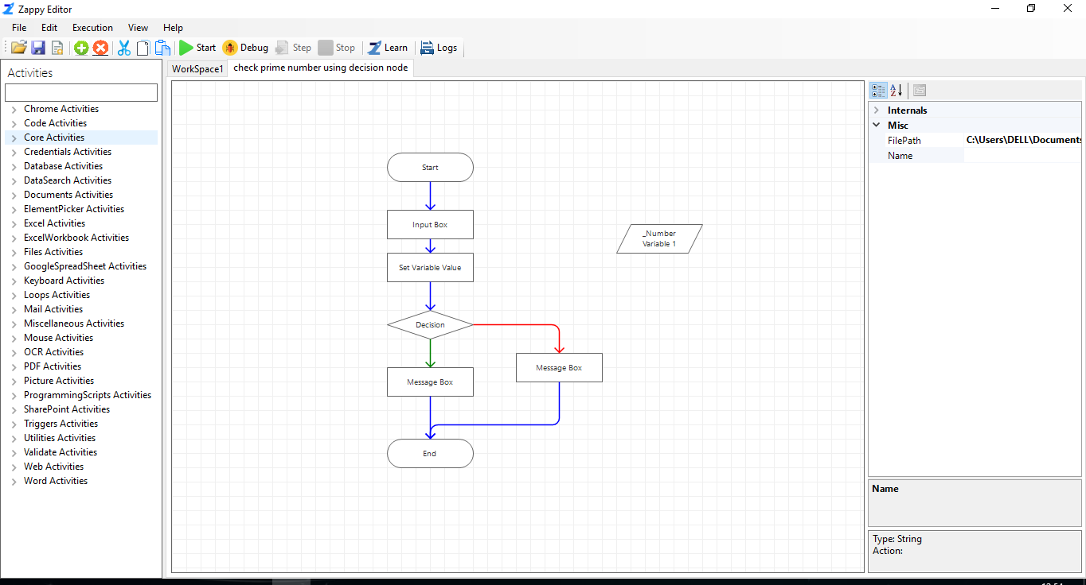

**Step 3:** To start the execution, click on the **start** icon  .

**Step 4**: Enter any integer number in the input box and click on the **OK** button.

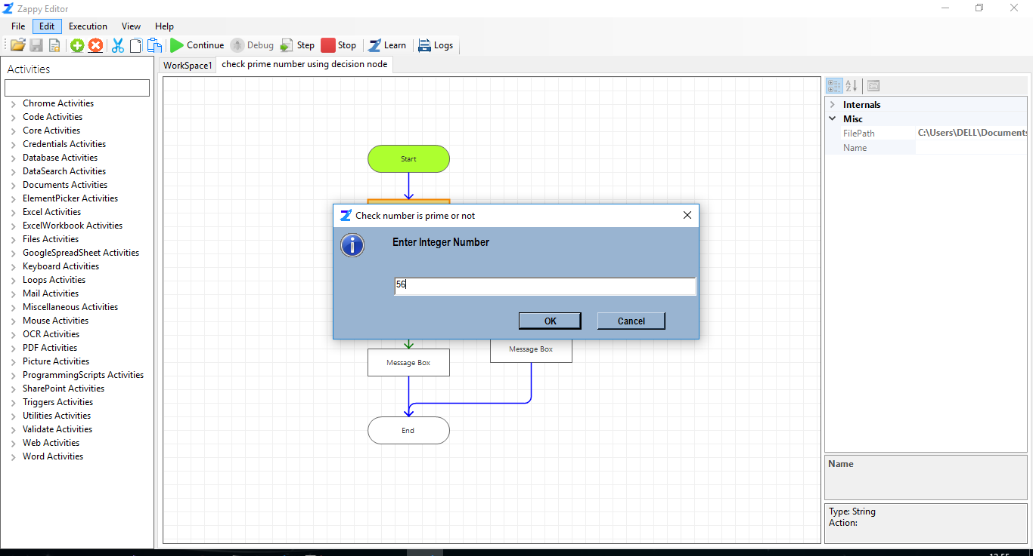

**Step 5**: Output will be show in message box then you have to click on **OK** button.

